**DAILY ONLINE ACTIVITIES SUMMARY**

|  |  |  |  |  |  |  |  |
| --- | --- | --- | --- | --- | --- | --- | --- |
| **Date:** | **18-05-2020** | | | | **Name:** | **AMRUTHA G** | |
| **Sem & Sec** | **4TH SEM A** | | | | **USN:** | **4AL18CS006** | |
| **Online Test Summary** | | | | | | | |
| **Subject** | | **COMPLEX ANALYSIS, PROBABILITY AND STATISTICAL METHODS** | | | | | |
| **Max. Marks** | | **30** | | **Score** | | **10** | |
| **Certification Course Summary** | | | | | | | |
| **Course** | **JAVA PROGRAMMING** | | | | | | |
| **Certificate Provider** | | | **GREAT LEARNING ACADEMY** | **Duration** | | | **3.5 HOURS** |
| **Coding Challenges** | | | | | | | |
| **Problem Statement:1.Printing odd and even numbers using thread** | | | | | | | |
| **Status:Executed** | | | | | | | |
| **Uploaded the report in Github** | | | | **YES** | | | |
| **If yes Repository name** | | | | **https://github.com/AMRUTHAGANESH/lockdown-coding-** | | | |
| **Uploaded the report in slack** | | | | **YES** | | | |

**Online Test Details:**

The online test was from module 4 which was about curve fitting and statistical method.

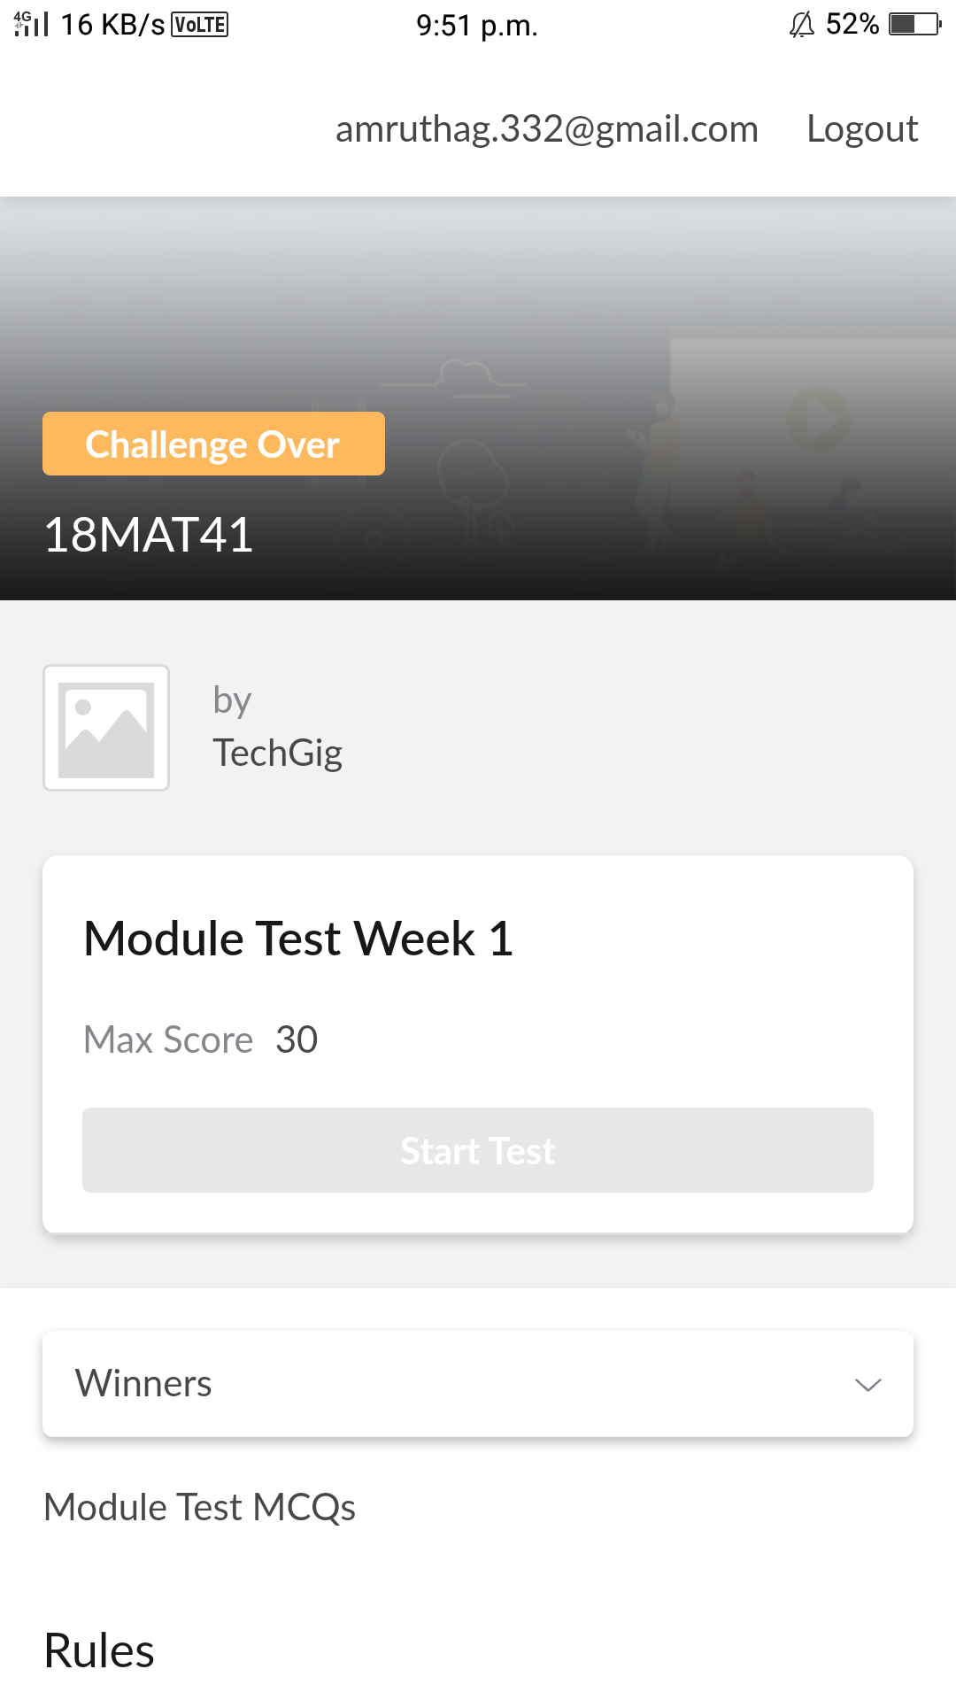

**Certification Course Details:**

Course Name:JAVA PROGRAMMINGIn java programming course shows new users how to create an account and in this course there are different module's

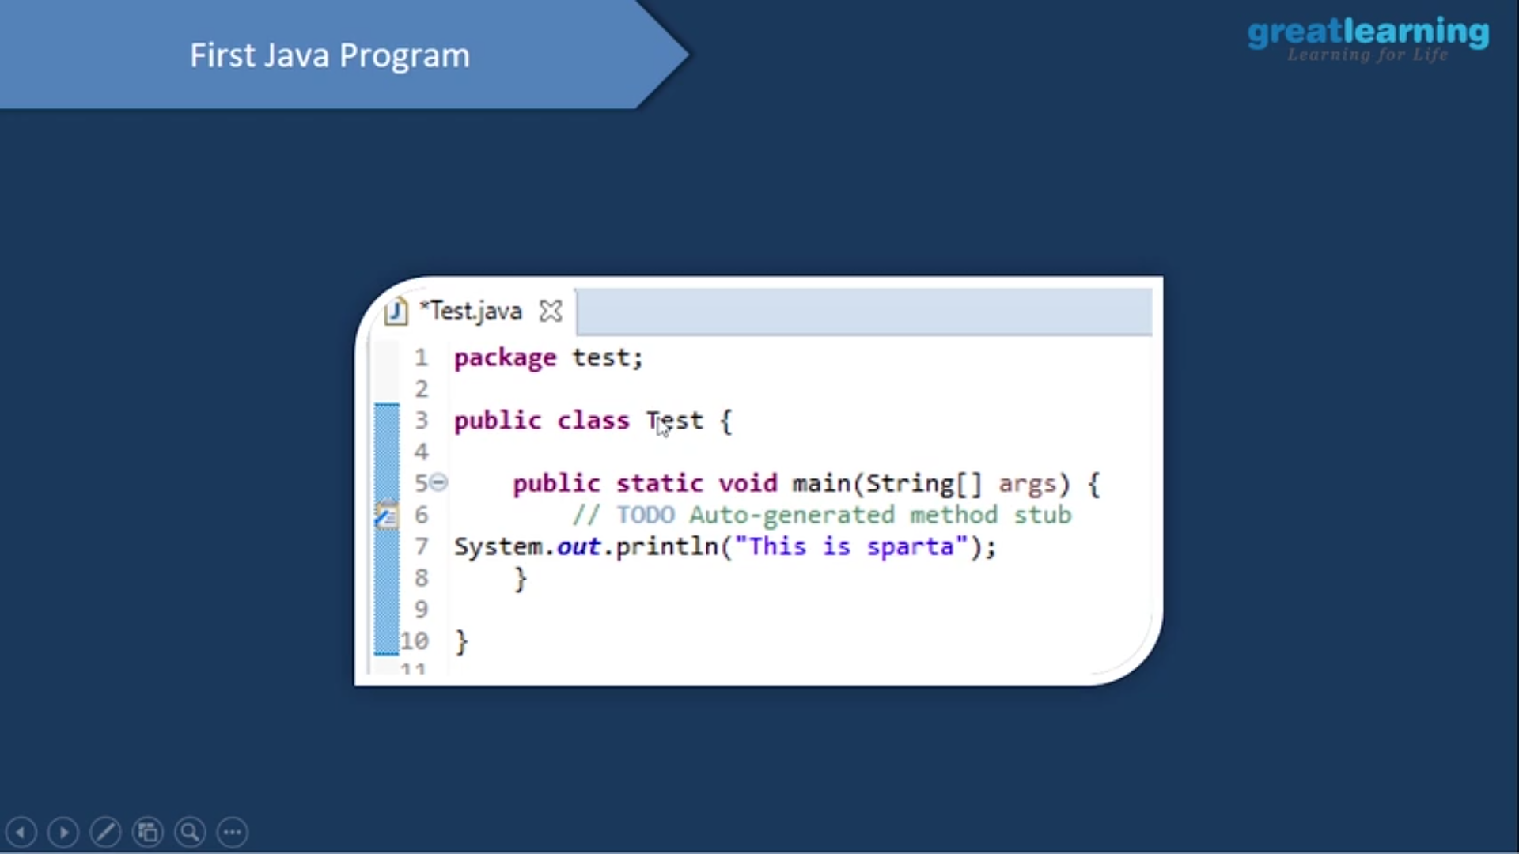

**Coding Challenges summary:**

Today I had received programs from Prof..Venkatesh Bhat(Dept. Of C.S.E). The program was To printing the odd and even numbers using threads.

Solution : uploaded in my GitHub account

